EC-2 Challenges

Launch one EC2 instance using Amazon Linux 2

Launched Amazon linux-2 instance in EC2
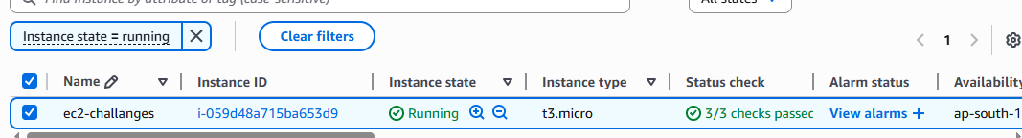

Install Docker
connect to instance and access to root
install docker in that instance by using command “yum install docker”
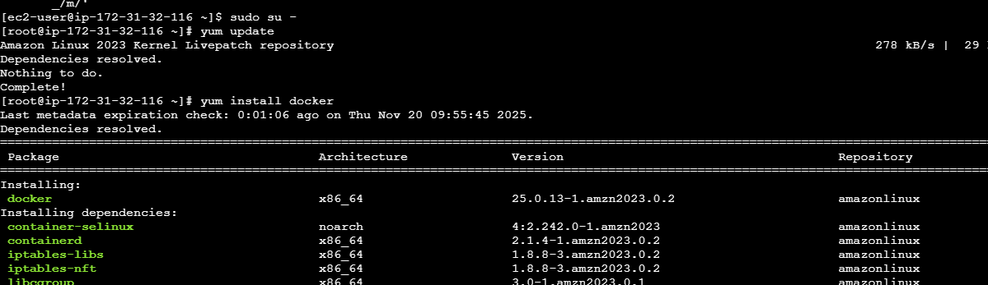
Check the docker version by using command “docker version”
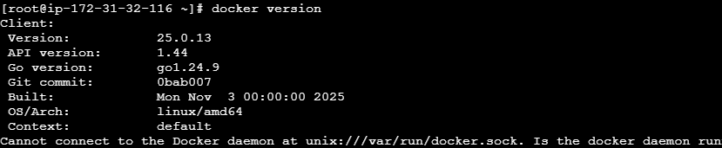

Install Jenkins.

install java by using command “yum install java”
check the java version “java -version”
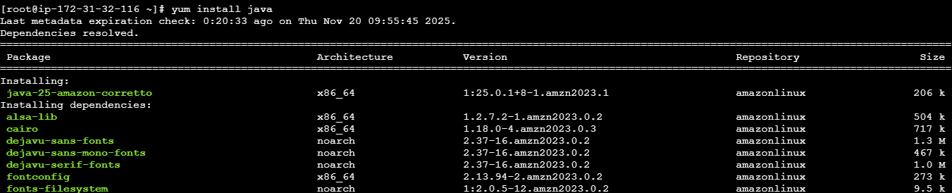
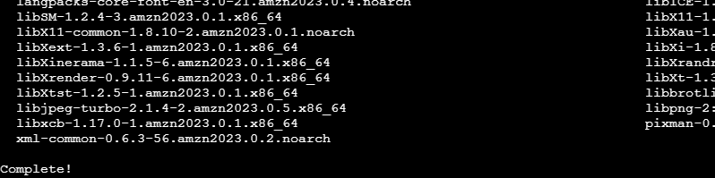
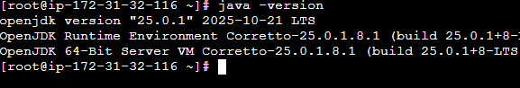
Now install Jenkins by using command “yum install Jenkins”
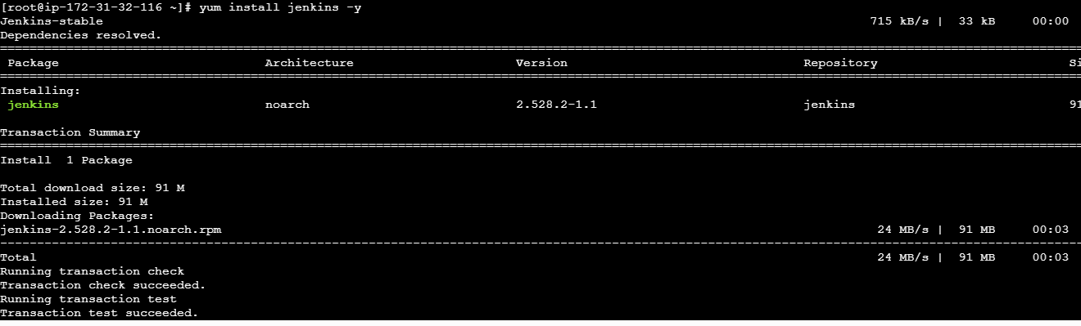
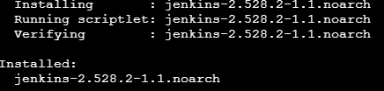
Systemctl start Jenkins to start the jenkins service
Systemctl status Jenkins to check the service is running or not
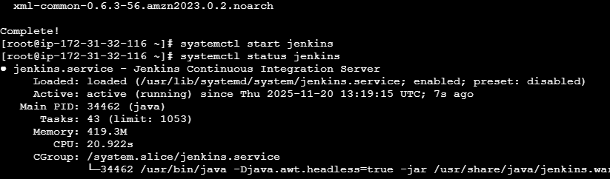
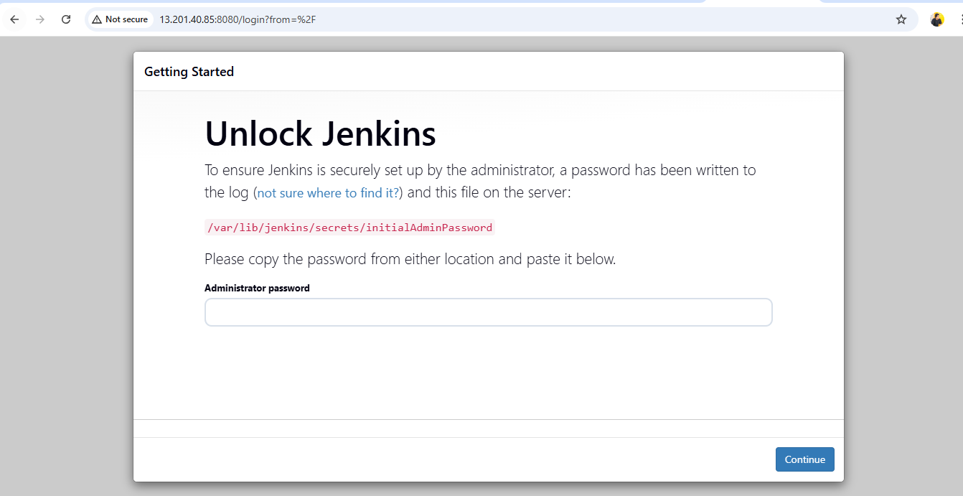

Install Apache.

To install apache use the commands:c
Yum install httpd
Systemctl start nginx
Systemctl status nginx
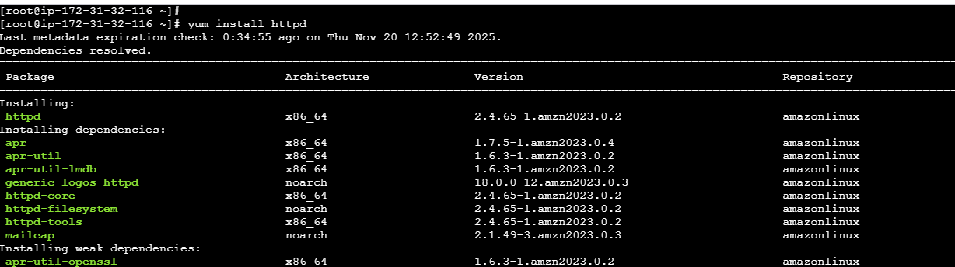
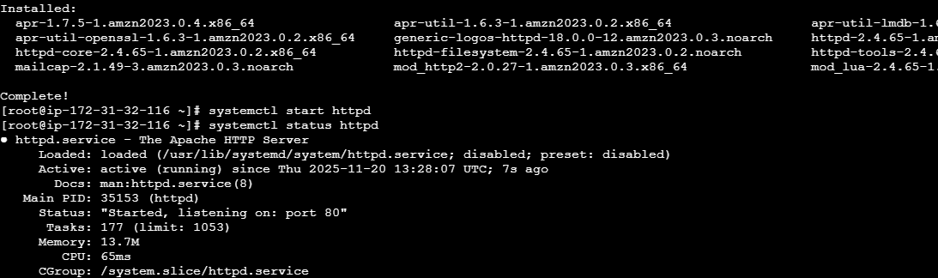
Changed the port number from 80 to 81 for httpd.
Vi /etc/httpd/conf/hhtpd.conf
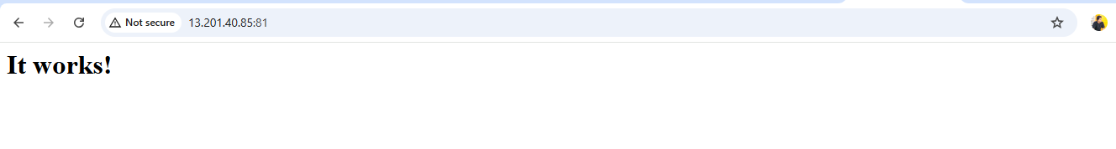

Install Nginx.
To install nginx execute commands:
Yum install nginx
Systemctl start nginx

To check the status of nginx service
Systemctl status nginx
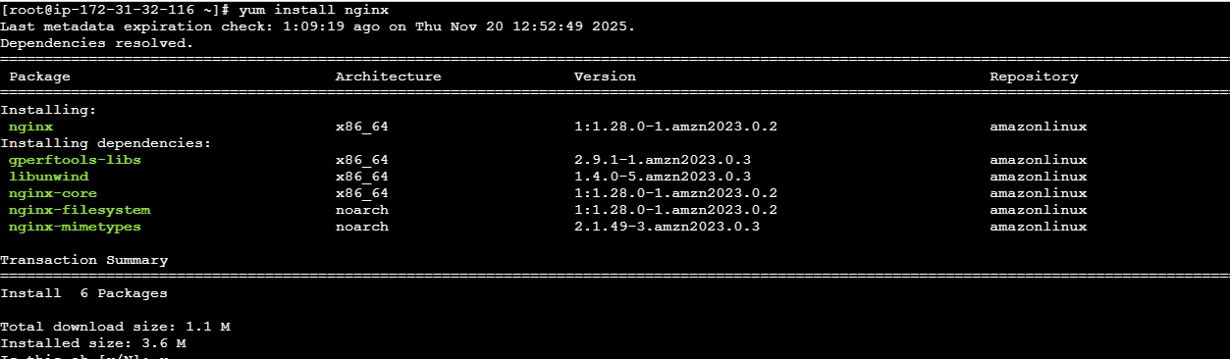
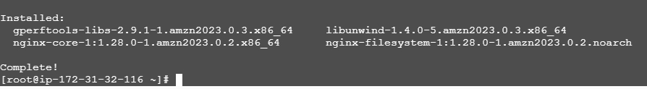

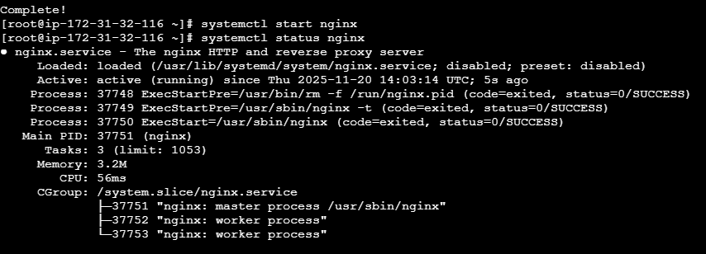
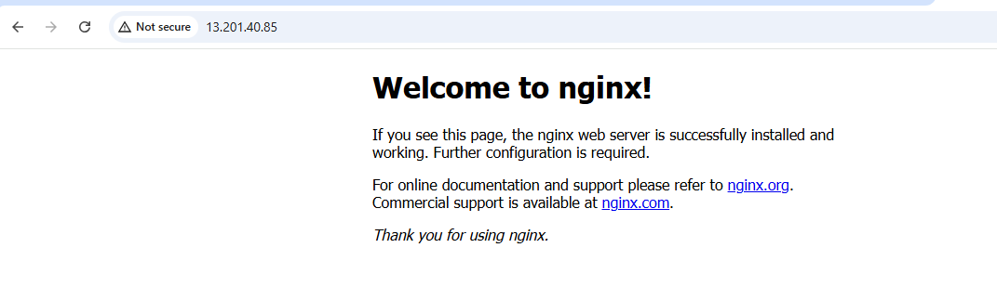
Install Apache Tomcat.

To install Tomcat copy the link of tomcat version tar file
By using “wget paste the link of tomcat tar file” do this in opt directory.
Extract the tomcat by using “tar xvf tomcat”
Go to tomcat directory from there
Go to conf directory from there
Edit the server.xml file to change the port number
Go back to bin directory and start the tomcat service “./startup.sh
Tomcat started.

